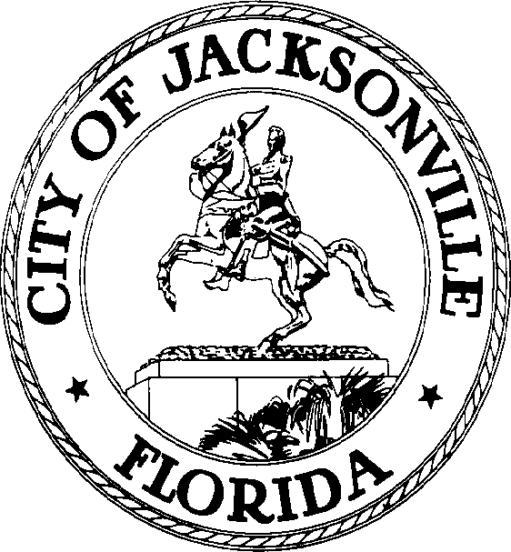

SAM C. NEWBY  Council President Group 5, At-Large  E-Mail: snewby@coj.net | OFFICE OF THE CITY COUNCIL | 117 West Duval Street City Hall, Suite 425  Jacksonville, Florida 32202  Office (904) 255-5219  Fax (904) 255-5230

April 5, 2022
3:30 P.M.
MEETING NOTICE

Notice is hereby given that UF Health will hold a Community Call for the Jacksonville City Council and other community leaders. This meeting will be held, Thursday, April 7, 2022, at 10:00 am. by teleconference. To participate, members of the public can call using the following information:
Call-In# - 1-855-949-3274 Conference ID# - 7153982
All interested parties are encouraged to attend.
For additional information, please contact Pamela Wilcox, Secretary to the President, Council Member At-Large, Group 5, (904) 255-5163.
ADA Accommodation Notice:

Pursuant to the American with Disabilities Act, accommodations for persons with disabilities are available upon request. Please allow 1-2 business days notification to process; last-minute requests will be accepted but may not be possible to fulfill. Please contact Disabled Services Division at: V 904-255-5466, TTY-904-255-5476, or email your request to KaraT@coj.net.

CC: Council Members and Staff
Director/Council Secretary
Jessica Matthews, Chief Legislative Services Division
Jeff Clements, Chief Research Division
Yvonne Mitchell, Chief Administrative Services Division
CityC@coj.net
Electronic Notice Kiosk-1st Floor City Hall
Public Notice System – City Council Web Page
Media Box
File Copy

